KUBERNETES TASK-07
- Task 1: Execute all yaml files shown in video.
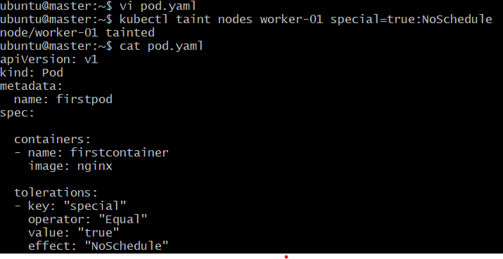
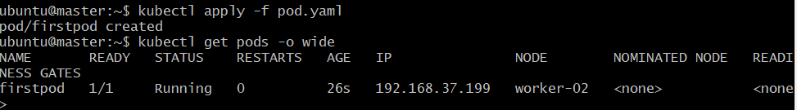
- Task 2: Taint a Node and Schedule a Tolerant Pod Taint a node with special=true:NoSchedule. Create a pod with a toleration that matches the taint, allowing it to be scheduled on the tainted node.
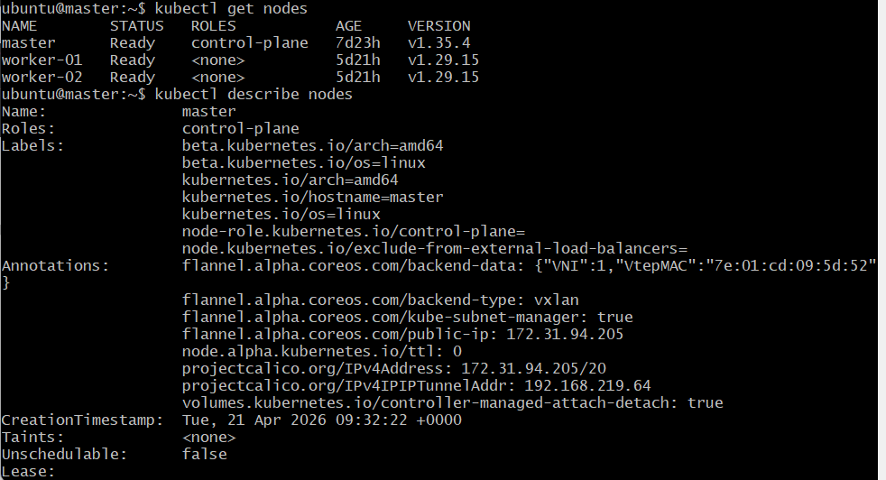
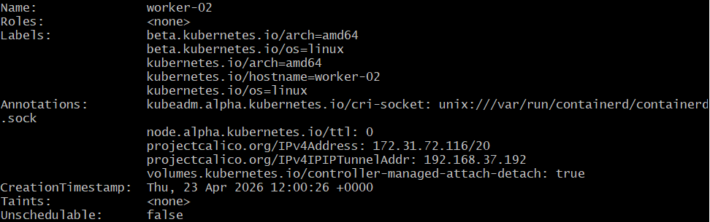
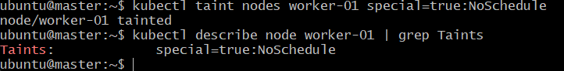
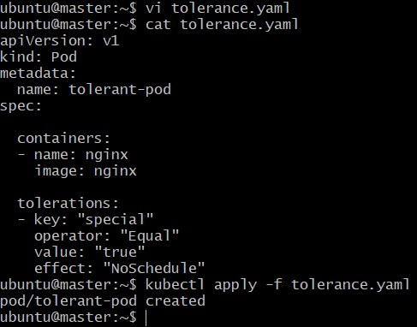
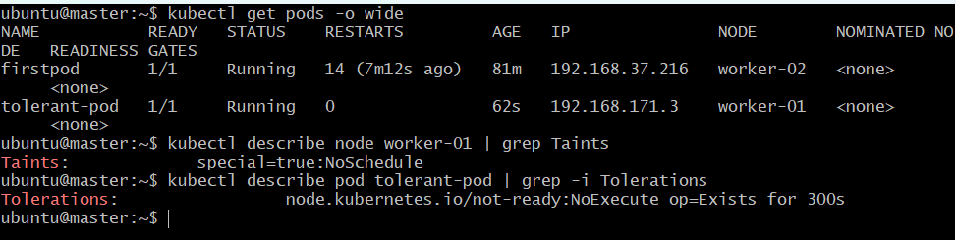
- Task 3: Use NodeSelector to Schedule a Pod on a Specific Node Label a node with env=dev. Create a pod with a nodeSelector that schedules it only on the node labeled env=dev.
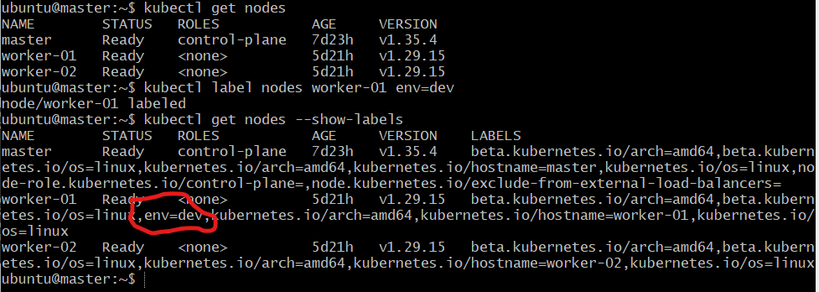
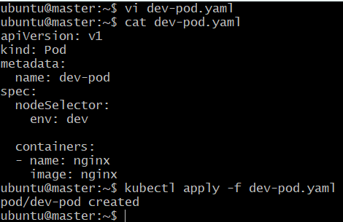
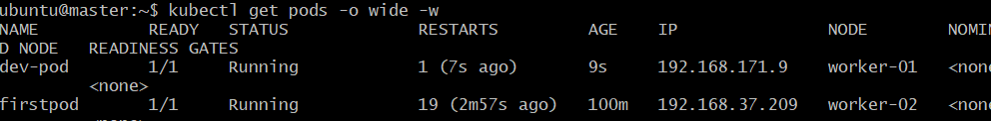
- Task 4: Use Node Affinity with Soft Scheduling Label a node with env=test. Create a pod with PreferredDuringSchedulingIgnoredDuringExecution node affinity, preferring to schedule it on a node labeled env=test. Remove the label and verify the pod continues to run.
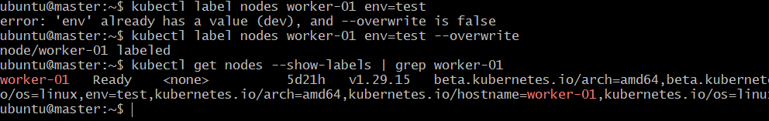
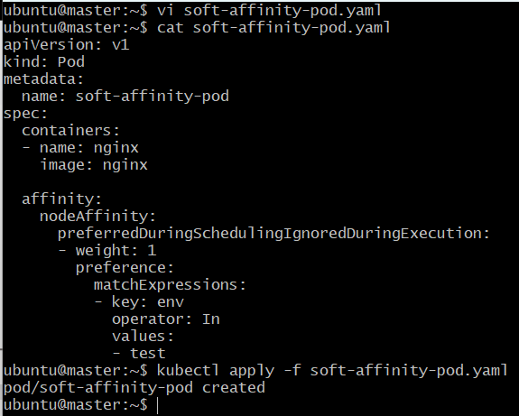
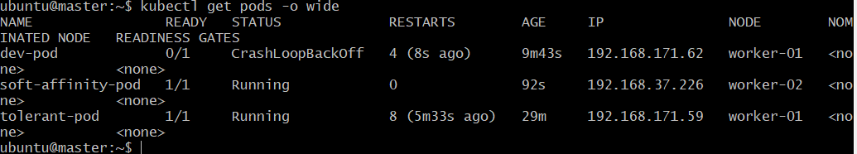
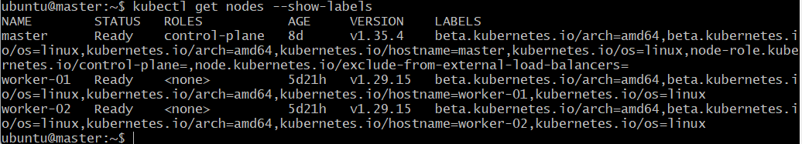
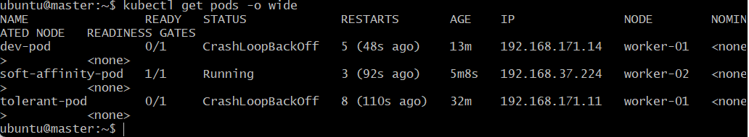
• Task 5: Implement Node Affinity with Hard Scheduling Create a pod with RequiredDuringSchedulingIgnoredDuringExecution node affinity, ensuring it will only be scheduled on a node labeled env=prod. Verify the pod cannot be scheduled if no node has the env=prod label.
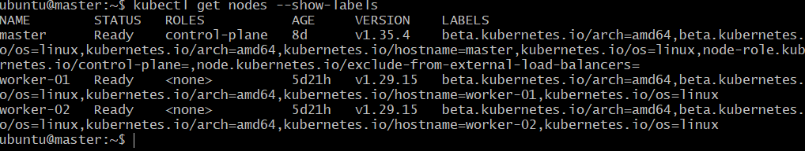
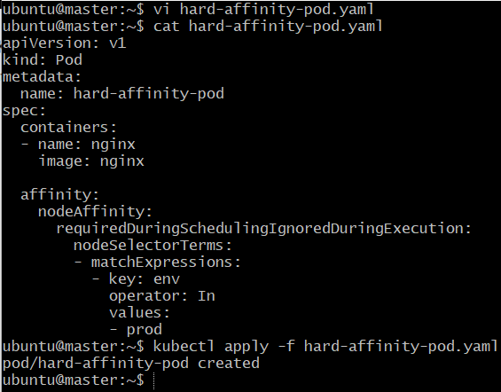
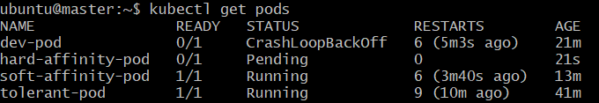
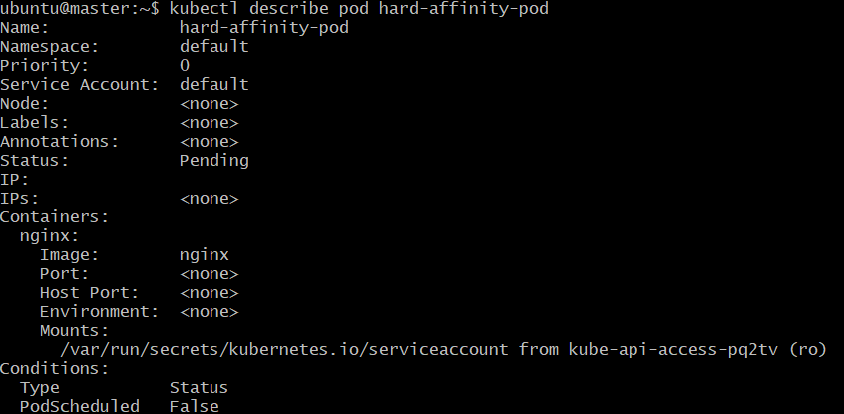
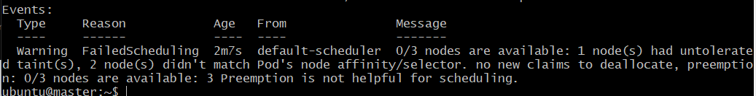
- Task 6: Taint a Node and Use NoExecute with Toleration Seconds Taint a node with special=true:NoExecute. Create a pod with a tolerationSeconds field (e.g., 60 seconds) and observe it gets evicted after 60 seconds on the tainted node.
